**External Documentation-Help System**

Video Rental is designed to be quick and efficient, it allows users to manually sign out movies that they want to watch. The following steps explain the process of renting/returning movies.

**Step 1**

If you are a new user, enter your full name and press “Enter” (Eg. John. Smith)

OR

If you are a return user, enter your full name and press “Enter” (Eg. John Smith)

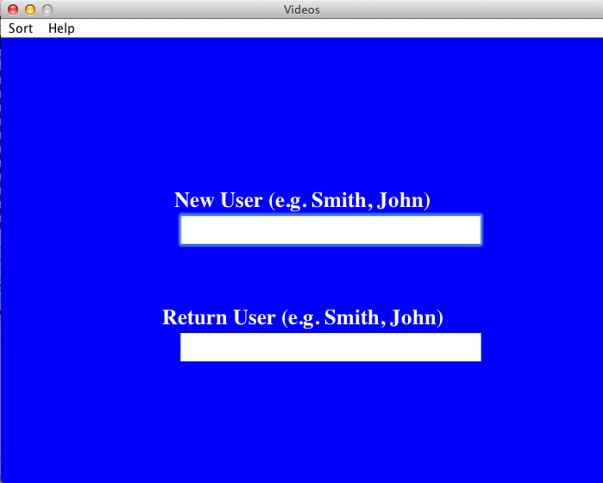

**Step 2**

Return User:

Choose whether you want to rent movies **OR** return movies

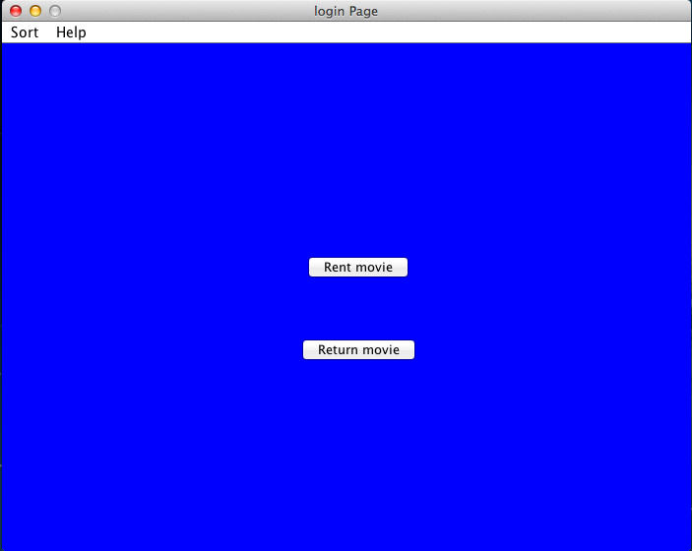

Option 1: Rent Movies

Enter the movie name that you would like to rent and click “Enter”, double check the spelling and capitalization (Eg. Deadpool)

Option 2: Return Movies

Enter the movie name and click “Enter” until you see “Record deleted”

New User:

Enter the movie name that you would like to rent and click “Enter”, double check the spelling and capitalization. (Eg. Deadpool)

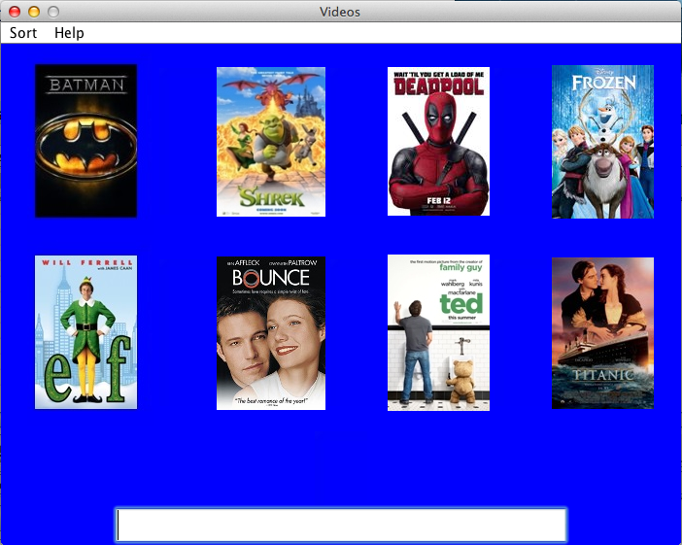

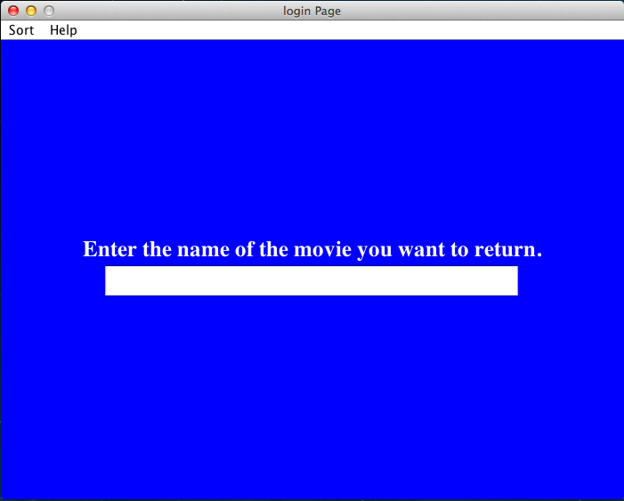

**Step 3**

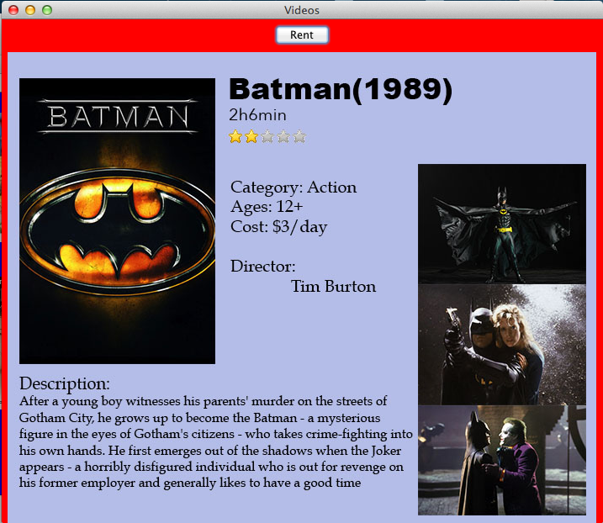

New User& Return User:

A detailed description of the movie you have chosen will pop up; click “Rent” on the top if you would like to rent the movie. (Receipt will be printed below)

Ps: Users can always rent out multiple movies, just need to go through the process again!